ARC manual V3 notes:

**Restrictions**

rover design requirements:

* Weight limit – all installed systems within a mission should be under 60kg, every kg over 60 gets a 5% penalty. Total weight of all systems regardless of mission should be under 80kg
* Size limit – The missions of the challenge are designed for a 1.5m x 1.5m x 1.5m vehicle, with at least 30 degrees of slopes
* Cost – under 20k usd
* Others – there could be environmental conditions such as wind rain fog. The mission ground conditions could be but not limited to gravel, either loose or hardened soil, and fine particle sand

Rover safety

* green light when it’s remotely controlled

yellow light for when it’s autonomously controlled

red for when it’s disarmed

10% penalty for when activity light is not turned on during missions

* emergency button of dia at least 3cm should be on the rover and kept in a visible space. 5% penalty for not having one
* no limitation to cruising speed
* need to contact judge before using flammables

communication equipment

* antenna can be placed outside, and will need at least 10 meters of cable from base to antenna

antenna masts cannot exceed 3m, and need to be strongly anchored

* field can be 40m in diameter
* the equipment can be used by the law numbered 5809 of the constitution of the Republic of Türkiye: https://www.btk.gov.tr/uploads/pages/milli-frekans-plani.pdf

technical check in

the rover will be checked on orientation day, and need to have the following features:

* The rover should move at least 5 meters, do a 360 turn and push a button on a panel.
* The rover has an indicator light that works as stated in all modes.
* The rover has a vertical cylinder 2-3 cm in diameter at least 1 meter above the ground level to attach the Mission Module via a provided bracket.
* The rover shows it can be stopped remotely over RSCP communication
* The rover shows it has an emergency button at least 3 cm in diameter on the rover.
* The rover has to fit inside and be able to leave the airlock on its own.

ARC equipment mount

The rover must have a pipe as the connection point for ARC Rover Mission Camera and RSCP Module. The ARC Equipment Mount should;

* Top and Front sides are mostly open, not fully obstructed by the rover parts.
* The Pipe should be 25 mm in diameter and at least 10 mm long.
* The Pipe must be able to carry at least 1 kg of load.
* The pipe must be horizontal and at least 1 meter high from the ground.

**Definitions**

Challenge area

The challenge takes place in two separate fields: Moon Field and Mars Field.

The Mars Field is home to Science Mission and Night Mission, while the

Moon Field is home to Autonomous Mission and Collaboration Mission.

Mission fields

* only the field crew of the relevant team, the rover of the relevant team, and the judges can enter the mission fields and interfere with the field and the rover.
* watching the mission fields while other teams are competing will not be allowed.
* Mission fields will be overhauled for the next relevant team by the judges at the end of each mission
* There are two mission fields:

Mars Field: Includes Mars Base and resembles Mars surface by its color and features.

Moon Field: Includes Moon Base and resembles the Moon surface by its color and features.

Rover - Each rover will have a unique license plate for identification provided by the ARC Organization Committee.

Bases - They are closed areas that are located in the mission field and connected to the rest only by an "airlock". before each mission some time will be given to setup necessary equipment and antenna connections to base

Base Crew - The base team cannot communicate with the outside except the rover and judges during the mission.

Field Crew – 2 members, responsible for carrying the rover at the field in the beginning of the science mission or during intervention. Field crew stays at the base but can’t communicate with base crew. In case of interventions, the field crew gets the rover back to airlock in astronaut costumes

Judges –

Intervention –

During the mission, only the base crew can decide to intervene unless there is an emergency situation in the field.

Mission time will not be paused when intervention begins.

Team must inform the judges when they intervene. Then the field crew carries the rover to the airlock without communicating with the base crew.

Penalty for each intervention is indicated in the score table.

Rover can be interfered with at most 3 times. When the 4th intervention is performed, it is assumed that the team has decided not to continue the mission but is allowed to use the time remaining for testing purposes

As long as rovers drive and enter the airlock by themselves, the base crew can fix their rovers without getting an intervention. This does not count as an intervention.

Field Onboarding

Skipping –

Teams can skip the steps they want by informing the judge -they are not penalized in any way for it but mission time will not be paused.

If the team chooses not to skip, they should do the missions in order.

In case of a skip, they judge will make changes to the field accordingly and the teams are not allowed to touch the rover or the field during then.

Skipping rules for each mission:

**Science Mission:** Skipping applies. The teams can decide to try the skipped step again.

**Night Mission:** Each step can be skipped. However, if a step is skipped, it cannot be retried.

**Autonomous Mission:** Each step can be skipped. However, if a step is skipped, it cannot be retried.

**Collaboration Mission:** Skipping rules applies to Sensor Task. Rest of the steps can be retried

until the team completes it.

Field Dimensions – both fields are 40-meter diameter circles. Coordinate of center point will be provided

Coordinate System - EGM96 coordinate system, and (Lat: dd.dd., Long: dd.dd. Altitude: meters) format will be used when locations are given or requested. Ex: (41.100276, 29.020975, 53.96).

Criteria for “Reaching Target” –

"goes/returns near the target": distance between the outer surface of the object and the closest point of the rover to this surface is measured. (2 meters for Autonomous Mission and 1.5 meters for remaining unless otherwise stated)

If it is less than the requested distance the rover is considered to approach or arrive

Mission Module –

The mission module consists of a 360-degree camera and an RSCP communication module. This module will be connected prior to each mission. Make sure to have a long enough RS-232 cable with a D9-SUB connector to connect the module.

**Documentation**

Application

* Must complete challenge application form on the official ARC website
* Team info includes: “team name”, “list of the team members'', and “the contact information of the team leader and the team advisor”
* Team info must be submitted before design report.
* Join ARC community discord server

the candidate teams must report their work and electronically send the report together with the video they prepared

scoring parameters are stated in the Score Table. This score, combined with the video presentation score, will be used to rank the teams to select finalists.

Design Report

* The report must be prepared using the template provided on the ARC website
  + Arc 23 report template (only design report):

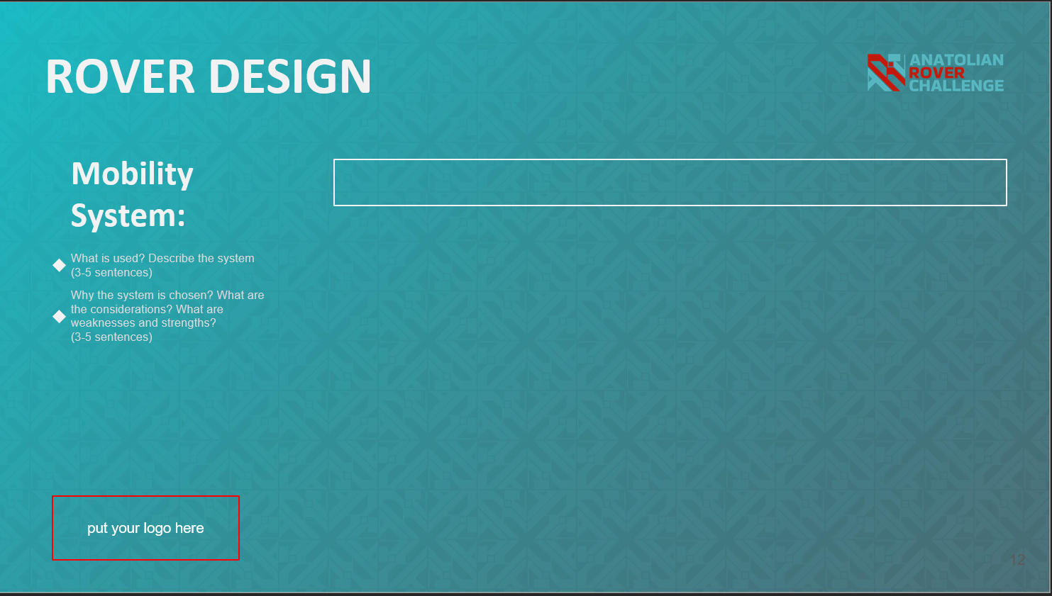

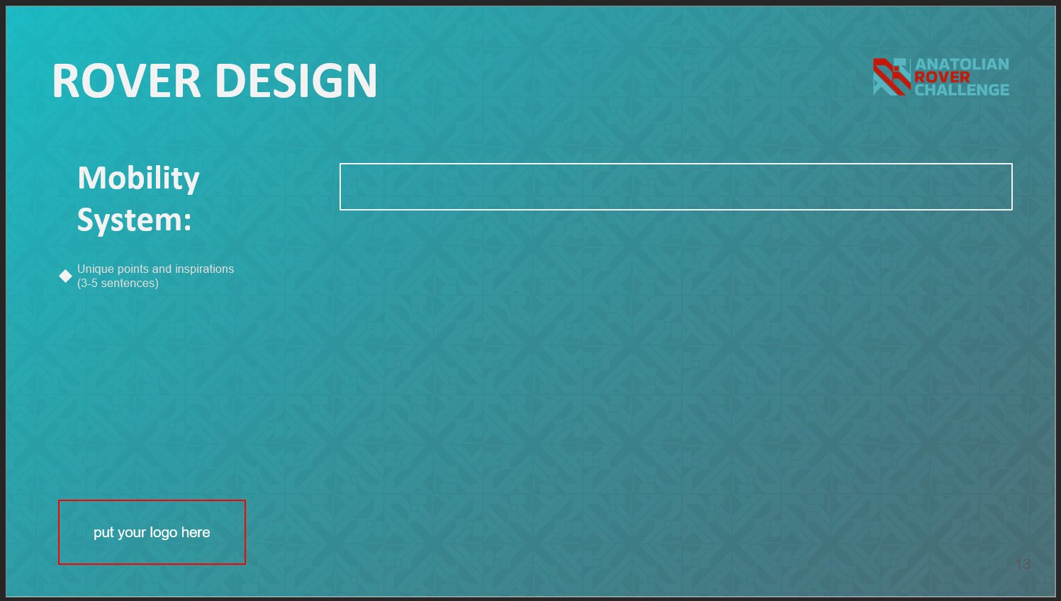

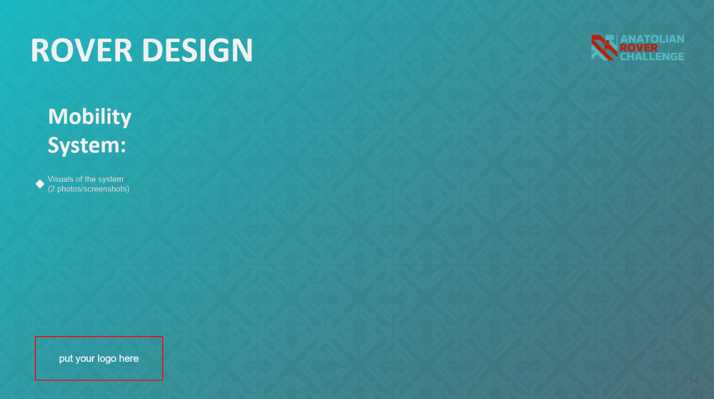

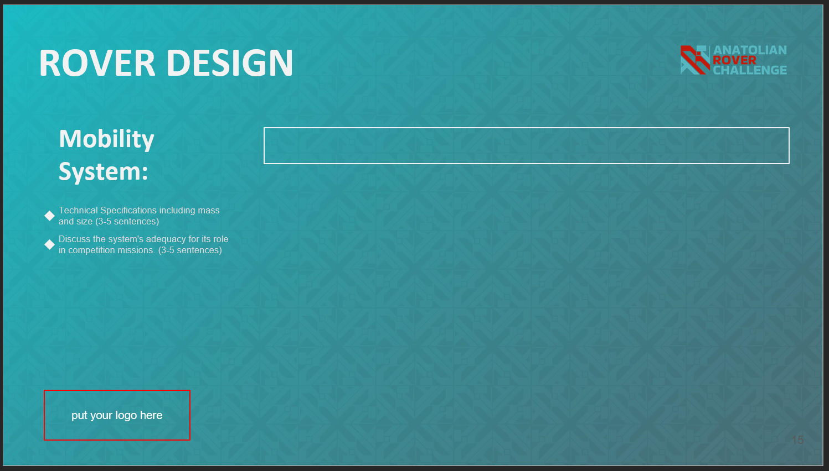

* There’s 4 main electrical subsystems -mobility system, electronics and power system, manipulation system (robotic arm) and science payload
* In each subsystem, we describe what is used, why the system is chosen based on pros and cons. The system’s unique points. Visuals of the system (2 photos, 3d model of the rover). the system’s adequacy for it’s role in the competition.

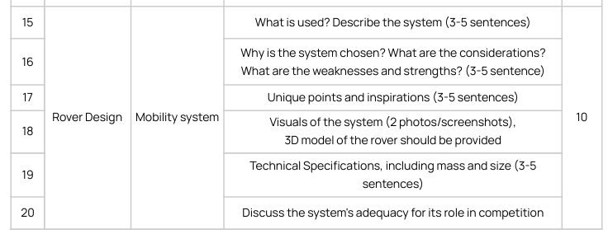

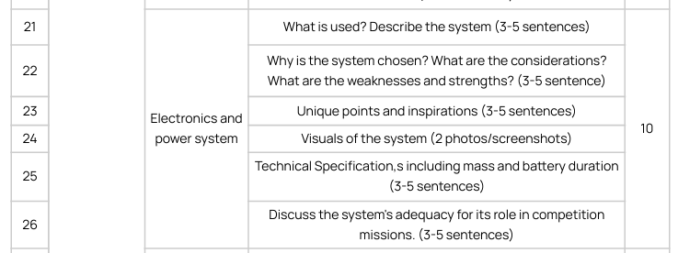

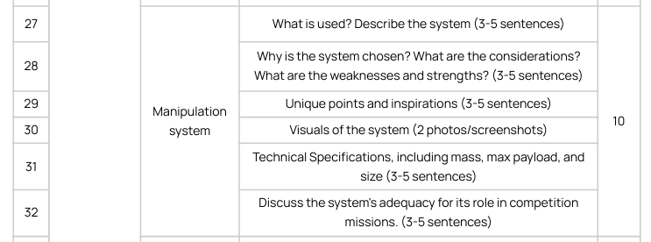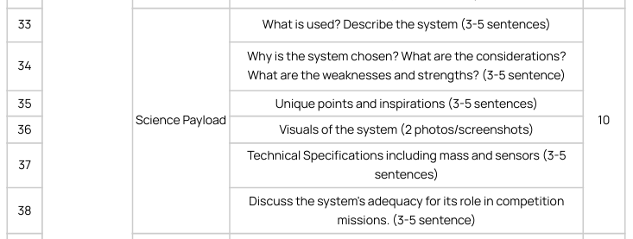

Video Presentation

* Upload video link
* Video should be published publicly on youtube
* Content duration is suggested to be from 6 to 10 mins, no more.
* There must be time stamps
* The video should include rover technical check in and ARC equipment mount.
* There’s 4 main electrical subsystems -mobility system, electronics and power system, manipulation system (robotic arm) and science payload
* What is used? Is the system chosen. Visuals of the system. Demonstrations with ARC24 mission in mind

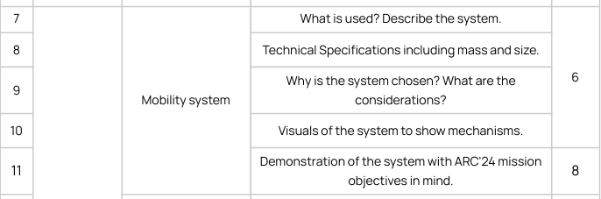

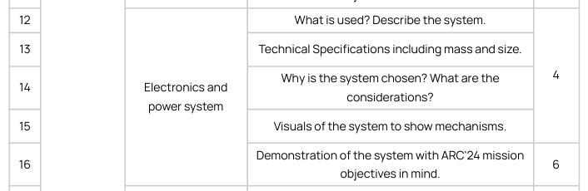

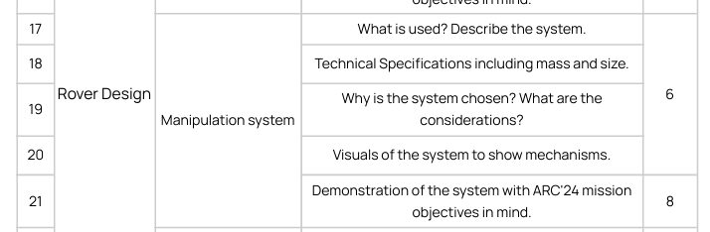

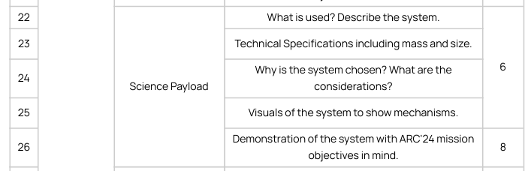

**Mission background**

Mars story

Day:

* Capturing panoramic images of landscapes
* Analyzing subsurface samples
* Teams have to explore their hypothesis about martian science

Night:

* Navigate through rugged terrain.
* Power up WISE (water ice subsurface extractor) and ensure it’s operation
* Moves WISE into place
* After reaching the location for WISE, the rover goes back to bring the power unit
* Then the rover returns to base and waits for water to get collected.

Moon story

* Setting up an antenna location
* Researching potential fuel sources for spacecraft
* Explore suitable regions for the mission and investigating a lava tube
* Lunar base requires maintenance and repair operations with the cooperation of many teams

**Missions**

Science mission:

* Time limit 30+10+10 mins
* Mission field: mars
* Part 1: landing and exploration
  + Start at the landing area
  + Survey the area -panoramic/stratigraphic pictures such that you can observe all the structures in the area
  + We indicate a sampling area in the science report. The sample should be taken using a drilling system at a minimum depth of 5cm and minimum weight of 5g. rover has to identify physical and chemical properties of the soil with the science kit.
  + Conduct onboard measurements using science kit
  + Preserve the sample in a closed and sealed container
  + Navigate to the second sampling area and do the same
  + Return to the airlock and handover the sealed samples to judges
* Part 2: experiments will be conducted in the base within 10 minutes
* Part 3: presentation:
  + Explain the mission area using photos taken. Interpret the geological structures
  + Explain the stratigraphy of the region
  + Explain the hypothesis submitted previously and why we selected the locations we did, the tests we did
  + Explain the sampling locations
  + Identify the sample
  + Explain the science kit
  + Explain the results by the science kit
* Scoring:

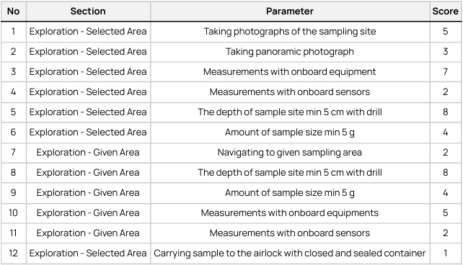

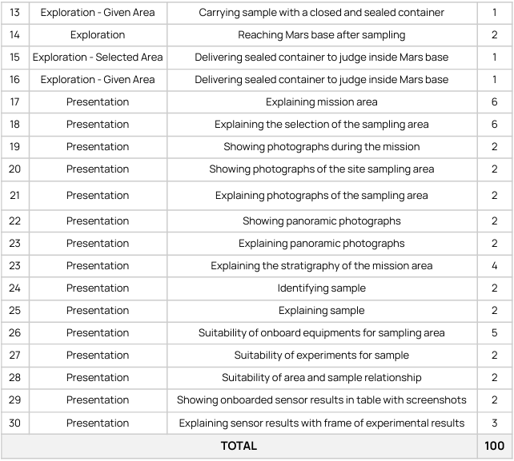

* Details:
  + Teams are not allowed to bring heat installing (electrical, gas, or portable), and there will
  + be no support for any heating activity (including kettle)
  + Teams are not allowed to bring flammable chemicals.
  + Strong chemicals (pH < 4 or pH > 12) are not allowed to bring more than 10 ml.
  + All chemicals and devices that will be used during the competition should be declared with
  + a science report, if teams do not confirm their setup and chemicals before the
  + competition, they will not be used during the competition.
  + Each team must bring a chemical declaration form before starting experiments. This
  + declaration will be signed by a judge and science team member.
  + Each team has to collect disposals before they leave the experimenting area.

Night mission

* Time limit 15 mins
* Mission field: mars
* Mission time: after sunset
* Steps:
  + Reach to WISE (Water Ice Subsurface Extractor). The rover starts by exiting the airlock and heads to WISE.
  + Move WISE to the sample site. WISE (4-wheel cart with towbar) is moved or towed to the sampling site.
  + Reach the battery center. The rover reaches the battery center.
  + Pick up a charged battery. The indicator lights will show battery capacity. The rover picks a charged one up.
  + Place the battery near WISE. Upon arrival at WISE, it safely places the battery near WISE.
  + Connect the battery to WISE. The rover forms a cable connection using a magnetic power cord.
  + Energize the battery. The rover powers WISE by pressing the power button on the battery.
  + Return to the airlock. The rover should enter the airlock so that no part of it is left outside.
* Scoring:

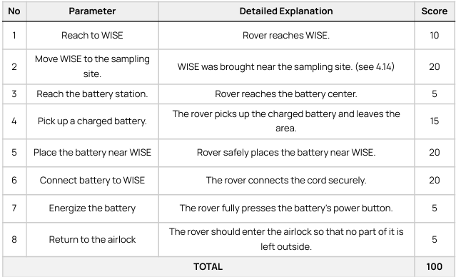

* Details:
  + The mission will be performed in the dark. Therefore, rovers should be prepared for night
  + operations.
  + Battery weight is less than 5 kg.
  + Power cord’s one end is already connected to WISE, and the other end is magnetic. It can
  + easily be attached to the battery terminal.
  + Teams are encouraged to explore the route that WISE will be moved along early in the
  + mission.

Autonomous Mission

* time limit: 30 minutes
* mission field: moon
* steps:
  + yellow light must be on
  + rover starts in the airlock

antenna deployment

* + go to antenna area using given coordinates
  + find the highest point within a 10 meter radius
  + install the antenna at the peak
  + transmit the peak coordinates via RSCP

Ice Search

* + move to the icy crater (10m dia)
  + locate and transmit the coldest point’s coordinates

lava tube exploration

* + navigate to the lava tube entrance using coordinates
  + enter the tube, detecting entrance markers
  + measure tunnel length using onboard sensors
  + exit and transmit the tunnel length via RSCP

return to the base

* + navigate back to the airlock
  + enter the airlock to complete missions
* scores:

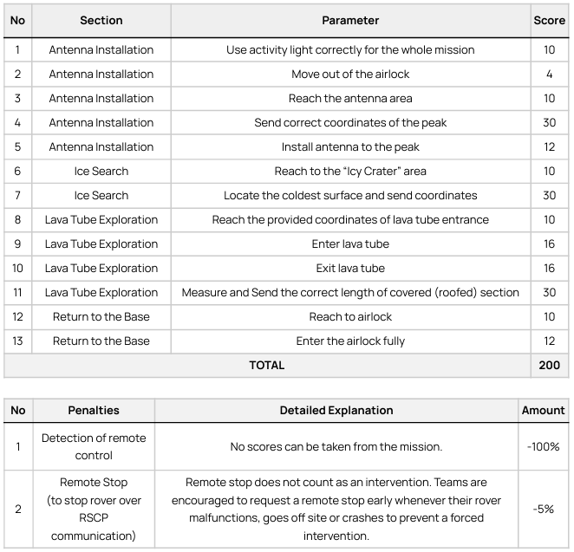

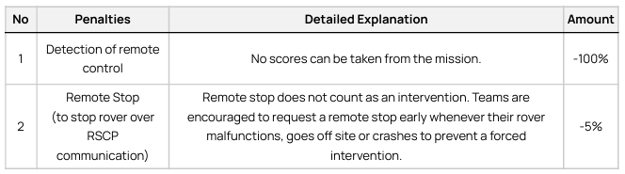

* details:
  + prohibited from communicating with our rover, including start stop commands
  + ARC crew ill provide a communication module to the rover and send mission directives to it. the rover is suppose to move only when it receives an assigned task, if it moved before that it’s penalized
  + There should be no antennas and the ARC judge will remove anything that resembles an antenna
  + In the preparation phase, teams are allowed to link their rovers to the Rover Satellite Communications Client Module (RSC-CM) using the RS-232 connection,.The RSC-CM operates using a unique message format named the Rover Satellite Communications Protocol (RSCP).

**RSC-CM**

* Equipped with a 9-hole DB9 female socket

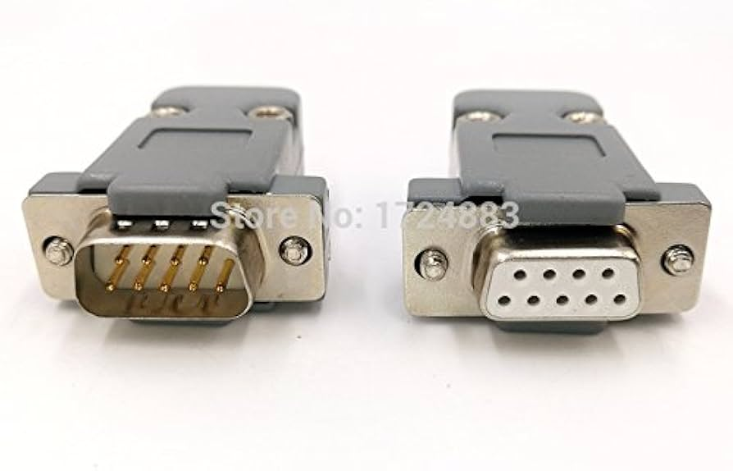

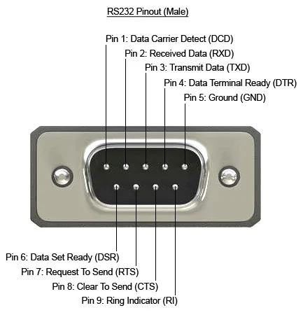

* Uses RS232 communication protocol
* Baud rate: 115200, 1 stop bit, no parity or additional stop bits